CIS 463
Microsoft SSIS Data Integration Exercise
Project Planning Services, Inc.

Overview
Project Planning Services, Inc. is a business consulting firm that provides technical and strategic services to its clients. They have several home offices, each of which houses a number of consultants. These consultants work on projects for PPS’s clients. Your task in this exercise is to build an SSIS package that will create a centralized database in SQL Server called PPSDB, and will import data into this database from a variety of sourced, including MS Access databases, Excel spreadsheets, and text files. The tasks you perform in this exercise are similar in many respects to what you did in the two SSIS tutorials. In addition, you will be working with more SSIS components, including OLEDB Command data transformations and VB Script tasks for performing customized operations.

Data Sources
I have provided several files for your use. These include:
- An empty MS Access database called PPS Empty Database.mdb containing the overall database structure that should be used when creating your PPSDB database. This consists of the following tables: Office, Consultant, ConsultantProject, Project, and Client. The relationships are shown here:
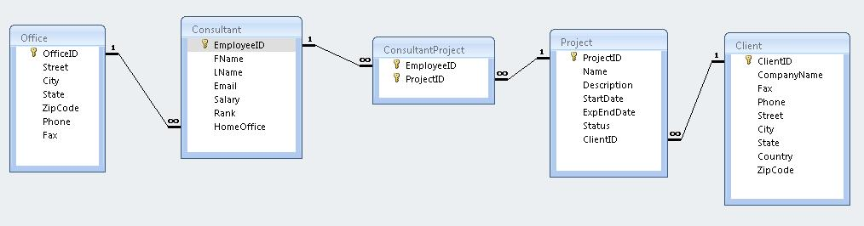

- Another MS Access database called PPS Core Data.mdb containing some of the core data for offices, consultants, projects, and clients. This is populated, but missing information, such as the consultant’s home office, the dates and statuses of the projects, and any consultant-project assignments. The format of this database is:
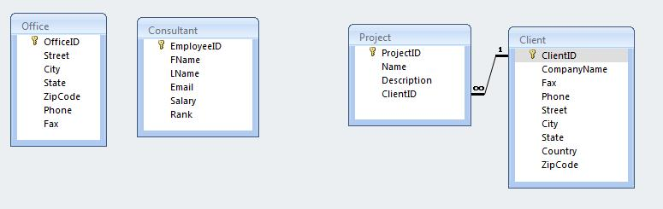
- Two Excel workbooks: OfficeConsultant.xls, and ProjectDatesAndStatuses.xls, which contain the home offices for each employee and the extra information of projects that are missing in the core data database.
- A folder called project assignments of text files, one for each project. These text files contain the people assigned to the project.

SSIS PROJECT DEVELOPMENT TASKS
Create Your BI Developer Studio Project
- Open BI Developer Studio and create an SSIS Project called ProjectPlanningServices.
Creating the PPSDB Database in SQL Server
- Create an OLE Connection Manager for localhost. Do not specify any database. You’ll be creating a new database in the next step of this exercise.
- In the Control Flow, insert an Execute SQL tasks for creating the PPSDB database Note: SQL allows you to create databases, just like you can create tables. This task should use the localhost connection manager you just created.
- Test it out. If it works, then you should be able to see the PPSDB database in Sql Server Management Studio.
Creating the Tables in the PPSDB database Based on the PPS Empty Database (MS Access)
- I provided you with an MS Access database called PPS Empty Database. Although this does not contain any data, it does contain all the metadata necessary for creating the tables in the SQL Server PPSDB database. You can take advantage of the SSIS Import and Export Wizard to produce the SQL script of all the CREATE TABLE commands.
- In the Solution Explorer, right-click on the SSIS Packages folder to start the wizard. In the wizard, choose the Microsoft Access PPS Empty Database as the source and the PPSDB as the destination. Just as in your first tutorial, this will create a new package that contains the Preparation SQL Task and the Data Flow task. Make sure you use localhost and the PPDSB database for your destination. The Data Flow task is irrelevant for our purposes, but the Preparation SQL Task will contain all the CREATE TABLE scripts if you follow the wizard steps correctly. This task should then be copied into the control flow of the first package you created earlier; it should follow the Create Database task.
- After you’ve done this, you should be able to remove the package that was created by the wizard; you won’t need it anymore.
- Note: After you’ve pasted the Preparation SQL Task into your working package, you’ll need to create a new connection for this task, again using localhost as the server, but this time specifying the PPSDB database.
- Drag the arrow from the Create PPS Database task you made in step 2 to the Preparation SQL Task. Note: this should not require the database creation to succeed, only to complete. If the database had already been created, the Create PPS Database task will fail.
- Test it out. If it works, then you should be able to see that the PPSDB database in Sql Server Management Studio contains the five tables from the Access database. These tables will all be empty.
- Now, you want to be able to drop these tables prior to creating them. So insert another Execute SQL Task for dropping the tables. This should contain five DROP TABLE commands, and it should be placed between the Create PPS Database task and the task that creates the tables.
- Test it out. Make sure you are able to drop the tables, and that they are then recreated. Verify in SQL Server Management Studio.
- At this point, your Control Flow space will have these tasks:
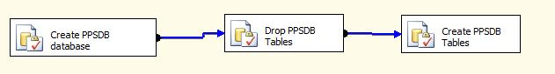

Loading data into the PPSDB database from the PPS Core Data Database (MS Access) using VB Scripts
- I provided you with an MS Access database called PPS Core Data. This contains the offices, consultants, clients and the projects for each client. In order to do this, we will be creating a Script Task for generating an ArrayList containing the table names, and then loop through that ArrayList to applying another Script Task for actually querying the source tables and populating each of the destination tables.
- Create a Connection Manager for this PPS Core Data database. To do this, in the Connection Manager area, right-click and create a new OLEDB connection manager. In the Providers list, choose Microsoft Jet 4.0 OLE DB Provider. The browse to the PPS Core Data database and select it.
- Create a variable called tblNames, of type Object. This variable will be used to contain the ArrayList from the VB script you create.
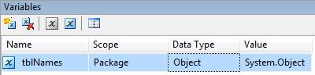
- Now drag a Script Task onto the Control Flow of your SSIS package. In the Script option, indicate that the tblNames variable will be a ReadWriteVariable. Also, set the PrecompileScriptIntoBinaryCode property to False.
- Click on the Design Script button. You’ll come into a VB editor. The purpose of this script is to generate an ArrayList of table names. This ArrayList will later be used to enumerate through for the actual data transfer from the Access database to the SQL Server database.
- Since you will be creating an ArrayList, you’ll need to import the System.Collections namespace. A namespace is in .NET like a package in Java. Put this statement among the Imports statements at the top of the script: Imports System.Collections
- Now put the following code in the script under the “Add code here” comment”
Dim tables As New ArrayList
tables.Add("Office")
tables.Add("Client")
tables.Add("Consultant")
tables.Add("Project")
Dts.Variables("tblNames").Value = tables

What we’re doing here is creating an ArrayList, adding the four table names to the list, and then assigning that list to the tblNames variable we created in step 16. This is an example of how you can use VB to customize tasks in SSIS.

- Connect the Create PPSDB Tables task to this one with an arrow. Then try running the package. If it works, the script task should appear as green:
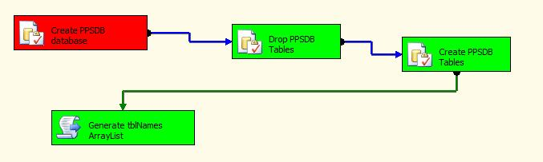
- Now that we have an ArrayList of table names, we can loop through these table names in order to perform the actions required from the tables of the PPS Core Data MS Access database to the corresponding tables of the PPSDB Sql Server database.
- Start by dragging a Foreach Loop container onto the Control Flow space. You’ve used this kind of container before in the 2nd SSIS tutorial for looping through files. This time, though, your enumerator should be set to a Foreach From Variable Enumerator. In the Variable Mappings create a new variable and call it tblName (singular). This variable should be of type String, and will be your enumerator for looping through the tblNames variable containing the ArrayList of table names. Go back to the Collections area; in the Enumerator Configuration, select this new variable tblName for your enumerator. At this point, your package will have two variables, and Object named tblNames and a String named tblName.
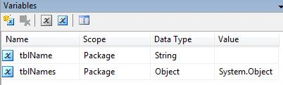

- Into this Loop Container, drag another Script Task. This task should have the tblName variable (your “loop counter” variable for looping through the tblNames ArrayList) as a ReadOnly variable. After doing this, your Control flow should show the following sequence of tasks:
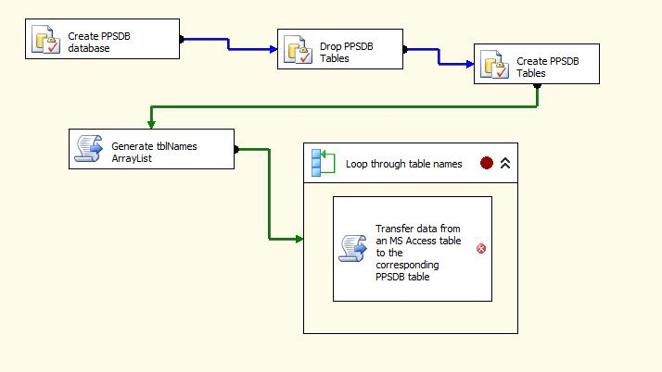
- Now, the Script for this task is a bit complex, but although its syntax is different from what you’re used to in Java, it should be familiar to CIS 484 students. To begin with, you need the following Imports statement in order to be able to use database connectivity (kind of like Java’s java.sql package…remember, .NET namespaces are analogous to Java packages):
Imports System.Data.OleDb

- Now, copy the following statements into the Main Sub, after the Add Code Here comment:

' set up the connections to the Access database and the SqlServer database
Dim con1 As OleDbConnection = _
New OleDbConnection(Dts.Connections("PPS Core Data").ConnectionString)
con1.Open()
Dim con2 As OleDbConnection = _
New OleDbConnection(Dts.Connections("localhost.PPSDB").ConnectionString)
con2.Open()

' get the table name via the loop enumerator
Dim tblName As String = Dts.Variables("tblName").Value.ToString

' set up the command and data reader for querying the Access database to obtain the
' data from the table specified by the enumerator
Dim sqlQuery As String = "select * from " + tblName
Dim command1 As New OleDbCommand(sqlQuery, con1)
Dim reader1 As OleDbDataReader = command1.ExecuteReader()

' set up the beginning of the sqlInsert string
Dim sqlInsertStart As String = "insert into " + tblName + "("
For i As Integer = 0 To reader1.FieldCount - 1
If i > 0 Then sqlInsertStart += ", "
sqlInsertStart += reader1.GetName(i)
Next
sqlInsertStart += ") values("

' for each record in the source table, do an insert into the destination table
Do While reader1.Read()
Dim sqlInsertStatement As String = sqlInsertStart
For i As Integer = 0 To reader1.FieldCount - 1
Dim fieldValue As String = reader1(i).ToString
If i > 0 Then sqlInsertStatement += ", "
Dim fieldType As String = reader1(i).GetType.ToString

If fieldType.Contains("String") Or fieldType.Contains("Date") Then sqlInsertStatement += "'"
sqlInsertStatement += fieldValue
If fieldType.Contains("String") Or fieldType.Contains("Date") Then sqlInsertStatement += "'"

Next
sqlInsertStatement += ")"
Dim command2 As New OleDbCommand(sqlInsertStatement, con2)
command2.ExecuteNonQuery()
Loop

NOTE: For you CIS majors, everything you learned about ADO .NET and JDBC has analogies here. You are setting up database connections. You are creating Commands, which are the same as JDBC Statements. You are using DataReaders, which are the same as JDBC’s ResultSets. And, you are using that same idea of looping through rows of a result set, with an inner loop going through the columns of a given row. And, you are taking the values from one result set and using them to construct dynamic SQL strings for inserting data into another database. See? Everything is the same wherever you go in the programming world. Nothing is new here. It’s just a matter of adapting the same sort of algorithm, the same basic idea, to a different syntax.
Save this. Attach your Loop Container to follow the script that generated the table names. At this point, your sequence of tasks would look something like this:
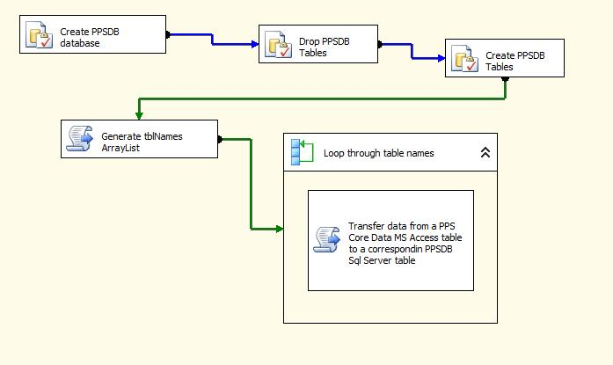
- Test it. If everything goes OK, you should see that the Loop container and its script task are green. Furthermore (and this is very important), you should see in Sql Server Manager Studio that the Client, Consultant, Office, and Project tables in your PPSDB database are actually populated.

Assigning Consultants to Offices using the OfficeConsultant.xls Excel Spreadsheet
- I provided you with an Excel workbook called OfficeConsultant.xls. This workbook contains a row for each employee of Project Planning Services. Each row includes the Office ID, the employee’s name, and his or her email address. Using this data, you will update the Consultant table in the Sql Server database accordingly.
- Drag a Data Flow task into the Control Flow. Give it the name Assign Consultants to Offices.Double-click on it; this brings you into the Data Flow tab.
- Drag an Excel dataflow Source onto the Data Flow area. For this, create a new connection manager, browse to your Excel workbook, and choose the OfficeConsultant worksheet. Go to the Columns section and verify that all four columns are chosen.
- Next, drag an OLEDB Command Data Transformation component onto the Data Flow space. Assign the localhost.PPSDB connection manager. Drag the arrow from the Excel Source to this component. Note: the OLEDB Command component will allow you to create a parameterized Update statement. This is not the same as the OLEDB Destination component that you had used in earlier tutorials, which were simply set up to target specific tables and had no capacity for SQL statement generation.
- In the Component Properties tab for the OLEDB Command, under Custom Properties, type the following SQL command:
update Consultant set HomeOffice = ? where Email = ?
Note: The question marks are parameters. You’ll see the results of this in the next step.
- In the Column Mappings tab, you should now see the Available Input Columns from the spreadsheet and parameters Param_0 and Param_1 in the Available Output Columns. Map OfficeID to Param_0 and Email to Param_1.
Parameterized queries are nice because they allow you to construct a SQL statement with “blanks” and “fill in the blanks” later. Here, we’re filling in the blanks with values mapped from the Excel worksheet, which is our data source containing the consultants’ home office assignments.
- Go back to the Control Flow. Right-click on the Assign Consultants to Offices data flow task and Execute it. If it works correctly, it will become green. Go into SQL Server Management Studio and verify that the home offices of the consultants have been correctly updates.
Control Flow:
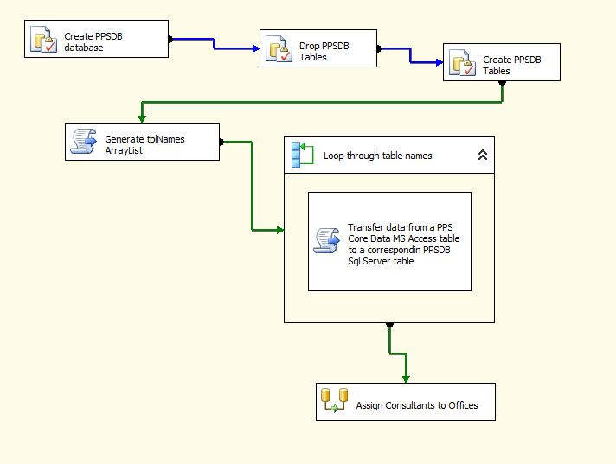
Data flow for the Assign Consultants to Offices task:
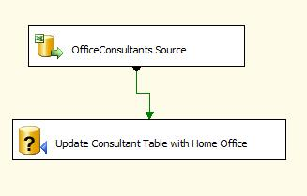

Assigning Consultants to Projects using Multiple Text File Sources
For this task, you will make use of the text files in the project assignment folder that I had provided. I’m going to turn you loose on this to try to solve it yourself. Use the same approach as in tutorial #2. Specifically, setting up the flat file connection like Lesson1/Task2 (use automobile.txt), then using that connection for the flat file source column specifications, then modifying connection to use variables instead of hard-coded name in a Foreach loop with files. Let’s see how you can do.
At the end, you should see the ConsultantProject table populated , and the control flow will look something like this:
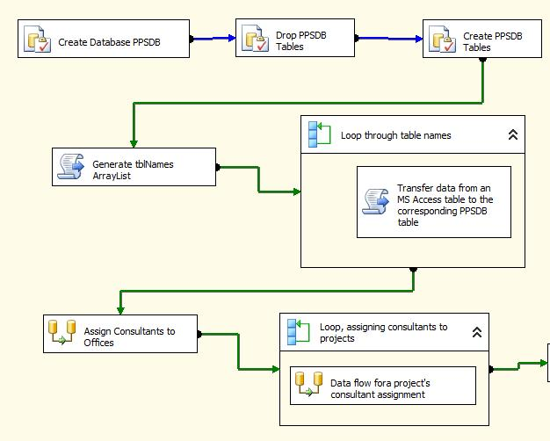

Setting up the Project Dates and Statuses
The approach to accomplishing this task is exactly the same as what you did with assigning consultants to their home offices. You will use the ProjectDatesAndStatuses.xls file and will your Data Flow task will include an Excel data source for the source data and an OLEDB Command for executing the parameterized update to the Project table.
So, after this, the Project table in the Sql Server database should include the project dates and statuses, and your control flow will look like this:
